Practical 1
Write the directory oriented commands with their options and outputs.
1.Directory Oriented Commands
pwd command The pwd command stands for (present working directory). It displays the current working location or directory of the user. It displays the whole working path starting with /. It is a built-in command.
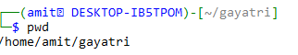
ls command List Files and Directories in Linux
The ls command is used to show the list of a folder. It will list out all the files in the directed folder.
ls -l | It will show the list in a long list format.

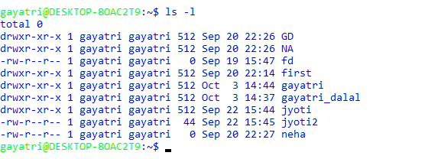

ls -a | The (ls -a) command will enlist the whole list of the current directory including the hidden files.
ls –d */ | It is used to display only subdirectories.

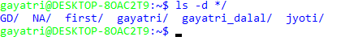

ls -p | Used to identify the directory easily by marking the directories with a slash (/) line sign

ls -r | It is used to print the list in reverse order

ls -R | It will display the content of the sub-directories also.

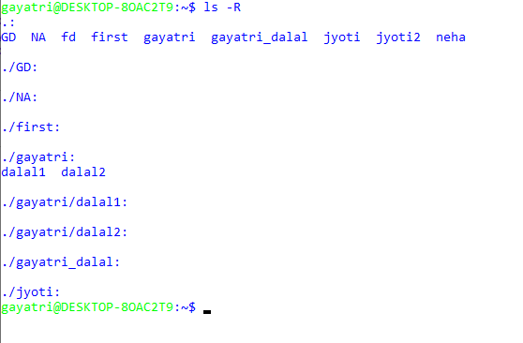
Ls -t
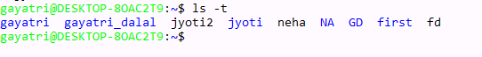

Ls –S

LS –X

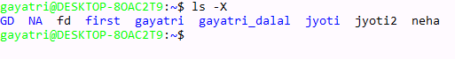
Ls –f

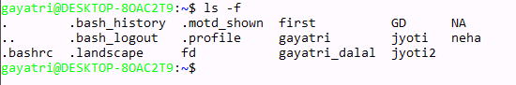

cd command The cd command stands for (change directory). It is used to change to the directory we want to work from the present directory.
mkdir command With mkdir command we can create our own directory.
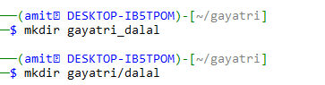
rmdir command The rmdir command is used to remove a directory from our system
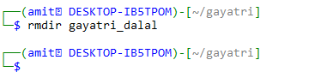

2. File Oriented Commands
Cat command It can be used to create a file, display content of the file, copy the content of one file to another file, and more
Touch command The touch command is used to create empty files.
Rm command
The rm command is used to remove a file.
Syntax:
rm <file name>

cp Command
The cp command is used to copy a file or directory.
Syntax:
To copy in the same directory:
- cp <existing file name> <new file name>
To copy in a different directory:

mv Command
The mv command is used to move a file or a directory form one location to another location.
Syntax:
mv <file name> <directory path>

cut

